**Q1: My PC has an INIT process with PID of 1. Check yours using terminal.**

**Ans:** 1

**Q2:** Output of the command: ls z*.c

**Ans:** List the files having names starting with z and ending with .c

**Q3:** Output of the command: chmod 770 test.c

**Ans:** Change permissions of file test.c to user and group only (read write and execute)

**Q4:** Output of following Shell command:

Captionless Image

**Ans:** sum is 140

**Q5:** If a process with PID=(Your regnumber) creates five threads using pthreads library, then what would be the PID of the last thread?

**Ans:** PID=Your registration number

**Q6:** Read and debug the problem THOROUGHLY. What would be the output.

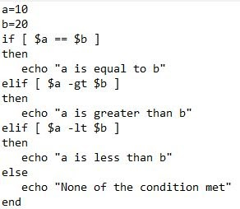

Ans: Error

**Q7:** Write 2 programs (in one c file). Create a zombie process in the first program and create an orphan process in the second program. Upload a screenshot of your output. The terminal's username must bear your name on it or the answer will be graded 0

**Ans:**

#include<stdio.h>

#include<unistd.h>

//ORPHAN PROCESS

int main()

{

fork();

printf("Parent Process ID:%d\n",getppid());

}

//ZOMBIE PROCESS

#include<stdio.h>

#include<unistd.h>

//zombie PROCESS

int main()

{

int pid;

pid=fork();

if(pid)

{

sleep(40);

}

printf("Process ID:%d\n",getpid());

}

orphan:

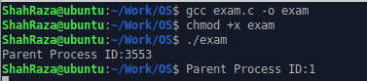

zombie:

